**EMERGENCY TRANSPORT SCHEME LOGBOOK**

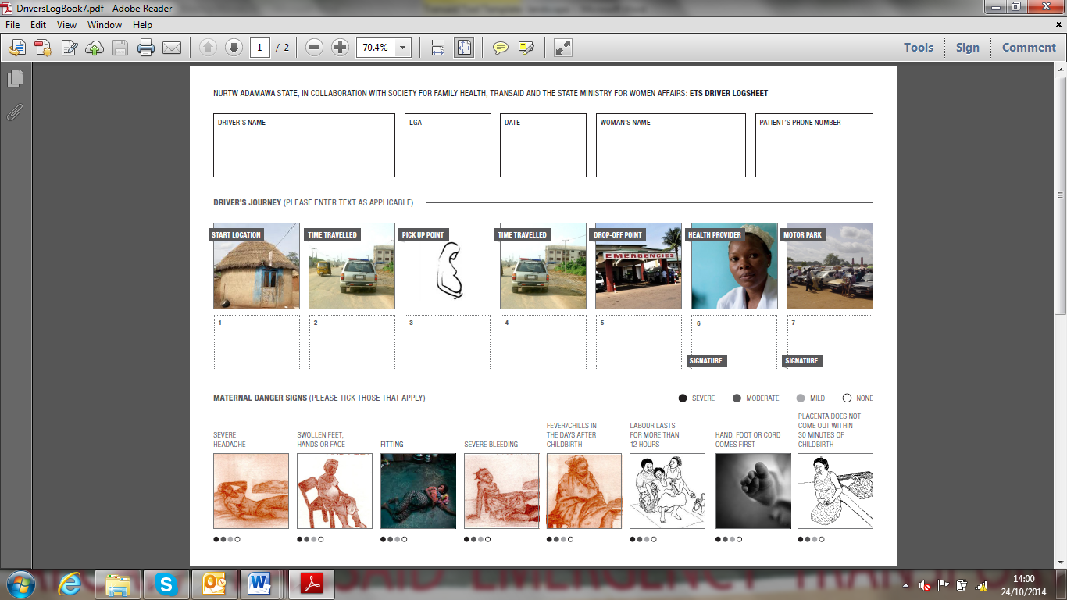**About this tool:** This logbook is to be used by drivers that are part of an emergency transport scheme to keep a log of the maternal cases that they transport to the health facility. It should be filled out every time they transport a maternal case.