**VEHICLE SPECIFICATION SHEET**

**About This Tool:** This tool can be used to check the specifications of Toyota Land Cruisers, such as weight and dimensions.

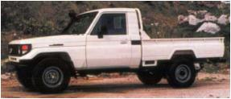

**TTOYLCPUH79L**

**Toyota Land Cruiser**

HZJ79, Pickup, diesel left hand drive

1950 Kg 16 m3

5.160x2. 115x 1.690m

**TTOYLCPIH79R**

**Toyota Land Cruiser**

HZJ79, pickup, diesel, right hand drive

1950Kg 16m3

5.160 x 2.115 x 1.690m

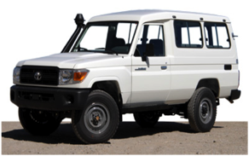

**TTOYLCSWH78L 13 Toyota Land Cruiser, Station wagon**

HZJ78, 13 seats, Diesel, left hand drive 2135kg 18.45 m3

5.160 x 2.115x 1.690m

**TTOYLCSWH78L 11 Toyota Land Cruiser, Station Wagon**

HZJ78, 11seats, diesel, left hand drive, 2135kg 1845m3

5.160 x 2.115 x 1.690m

**TTYOYLCSWH78L6 Toyota Land Cruiser, Station Wagon**

**HZJ78, 6 Seats, Diesel, Left Hand drive**

2135Kg 1845m3

5.160 x 2.115 x 1.690m

**TTOYLCSWH78R 13 Toyota Land Cruiser, Station Wagon**

**HZJ78, 13 Seats, Diesel, Right hand drive**

2135Kg 1845m3

5.160 x 2.115 x 1.690m

**TTOYLCSWH78RL Toyota Land Cruiser, Station Wagon**

**HZJ78, 11seats, Diesel, Right hand drive,**

2135kg 1845m3

5.160 x 2.115 x 1.690m

**TTOYLCSWH78R6 Toyota Land Cruiser, Station Wagon**

**HZJ78, 6 Seats, Diesel, Right Hand drive**

2135Kg 1845m3

5.160 x 2.115 x 1.690m