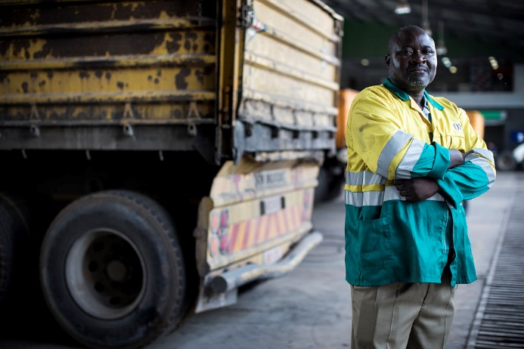
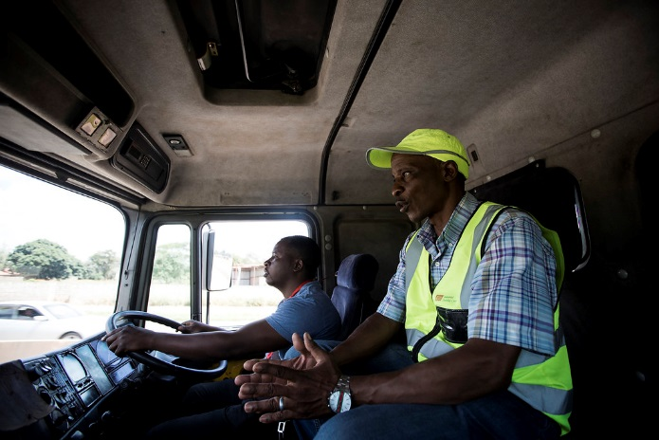
Why support the appeal?

Worldwide, road traffic crashes are the largest killer of children and young people aged 5-29 years. The problem is worst in low and middle-income countries, where 93% of road traffic fatalities occur despite only accounting for approximately 60% of the world’s vehicles (source: World Health Organisation).

Transaid works to create safer roads in sub-Saharan Africa. We are currently implementing professional driver training programmes in Tanzania, Uganda and Zambia, as well as recently embarking on a new road safety project involving motorcycles and three-wheelers in the Democratic Republic of Congo (DRC).

- Over the past 12 months, we have trained over 9,600 students in our professional driver training programmes.
- For over 10 years we have partnered with the Industrial Training Centre (ITC) in Lusaka, Zambia, to deliver driver training to internationally-recognised standards.
- Last year, trainers from the ITC travelled to Sierra Leone, where they delivered essential motorcycle training to 190 field officers working on a national education scheme.

With your help we can continue to make roads safer in Africa so that every driver can leave for a day’s work without the fear that they may not come home due to dangerous roads. Find out how below.

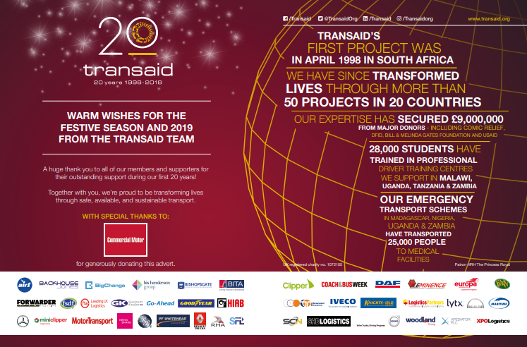
How to support our appeal:

Please decide how much you would like to donate and which thank-you package you wish to receive.

Packages include logo placement in our nine festive ads and/or an industry themed e-card design, personalised with your logo - saving on paper and the cost of posting traditional cards!

Fill out the form and email to jade@transaid.org or post to:
Transaid
Attn: Jade Ashby- Rozier
137 Euston Road
London, NW1 2AA

Last year’s Christmas Appeal advert in Commercial Motor Magazine, featuring logos from participating companies.

IMPORTANT!

* To guarantee entry, logos must be received by the following deadlines: 8th November for SHD Logistics, 11th November for Handling & Storage Solutions, 12th November for CILT Focus and UKWA Warehouse, 13th November for RHA Roadway, 19th November for FTA Logistics, 26th November for Forwarder and Coach & Bus Week, 2nd December for Motor Transport and Commercial Motor.

* All packages are subject to 20% VAT. Invoice and VAT receipt available on request

YOUR LOGO HERE
YOUR LOGO HERE

Choose one of the following e-card designs:
YOUR LOGO HERE
YOUR LOGO HERE

TRANSAID THANK-YOU PACKAGES:

GOLD PACKAGE – A donation of £800 (plus VAT) or more includes:
• Company logo placement in the Transaid festive advert in Motor Transport, SHD Logistics, Commercial Motor, Forwarder, Coach & Bus Week, CILT Focus, UKWA Warehouse and RHA Roadway* magazines
• A Transaid e-card personalised with company logo
• Company logo placement on the Transaid website
• Social media coverage

SILVER PACKAGE – A donation of £550 (plus VAT) or more includes:
• Company logo placement in the Transaid festive advert in Motor Transport, SHD Logistics, Commercial Motor, Forwarder, Coach & Bus Week, CILT Focus, UKWA Warehouse and RHA Roadway* magazines
• Company logo placement on the Transaid website
• Social media coverage

BRONZE PACKAGE – A donation of £350 (plus VAT) or more includes:
• A Transaid e-card personalised with company logo
• Company logo placement on the Transaid website

YOUR DETAILS:

Your name, Company & Title
Address
Phone number
Email
Package  (Please tick preferred option) | □ Gold □ Silver □ Bronze
Preferred e-card design  (For Gold and Bronze packages only) | □ Bicycle Ambulance □ Truck □ Forklift Truck □ Bus
Payment  (Please tick preferred option) | □ I’m enclosing a cheque payable to Transaid  □ Please invoice me for the above amount  □ I’d like to pay by BACS, please send me the details

Please ensure that you send a high-quality version of your organisation’s logo with your response, via email to jade@transaid.org. If you have any questions please contact Jade Ashby-Rozier at jade@transaid.org or 020 7387 8136.

